|  |  |
| --- | --- |
| Team ID | PNT2022TMID17579 |
| Project Name | Project – IOT Enabled Smart Farming Application |

IBM CLOUD SERVICE

DASHBOARD:

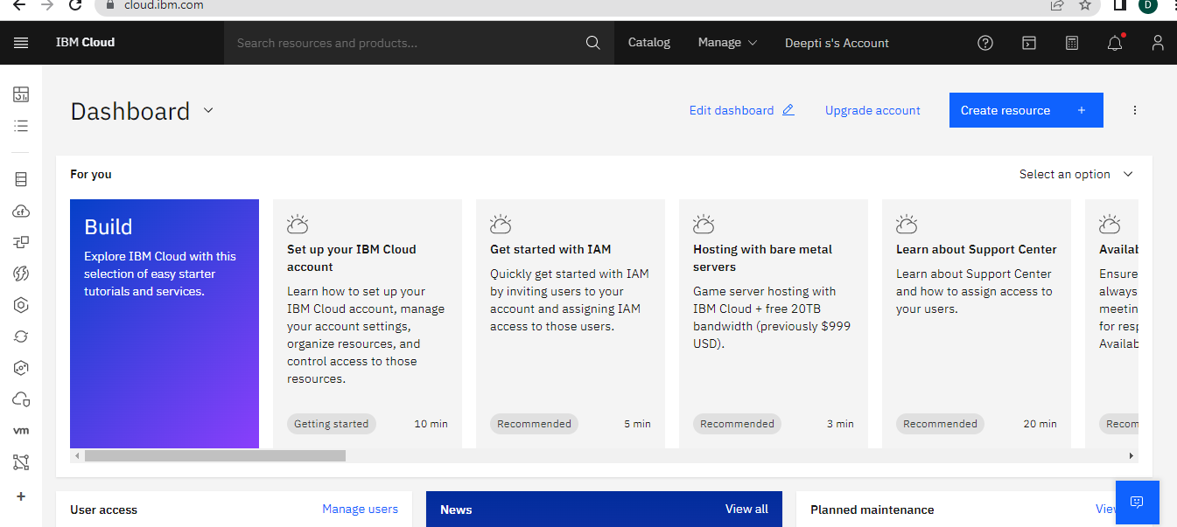

ACCOUNT SETTINGS:

